**Quick guide to the Ultimate-II+**

Thank you for purchasing the “Ultimate-II+” cartridge: The versatile storage solution for your Commodore 64 computer. Although the installation and use of the Ultimate-II+ are designed to be intuitive, this quick guide shows you the basic functions.

**Installation**

1. Unpack the USB stick, and use a PC or Mac to transfer your favorite floppy disk images (.D64 or .G64 files), tape archives (.T64 files), tape images (.TAP files), Amiga MOD files, SID music (.SID files), or separate programs (.PRG files) to your USB stick.

1. Insert the USB stick into one of the available USB slots on the Ultimate-II+.
2. Take the Ultimate-II+, and carefully slide it into the cartridge slot of your C=64. Connect the supplied serial cable between the serial port connector to the serial port of the computer. In case you want to use a configuration with a real drive, connect the computer to the drive first and then use the feed through of the drive to attach the Ultimate-II+ as the last device in the chain.

**Ports and buttons**

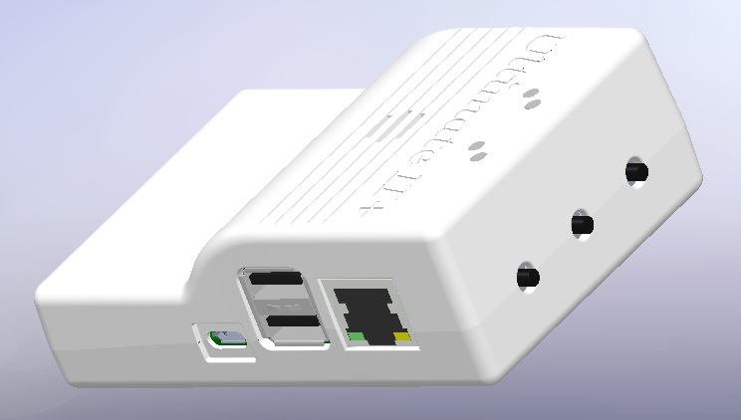

Optional

Speaker

Reset

USB 0

USB 1

Menu

MicroUSB

ext. power

100 Mbps

Ethernet

Freeze

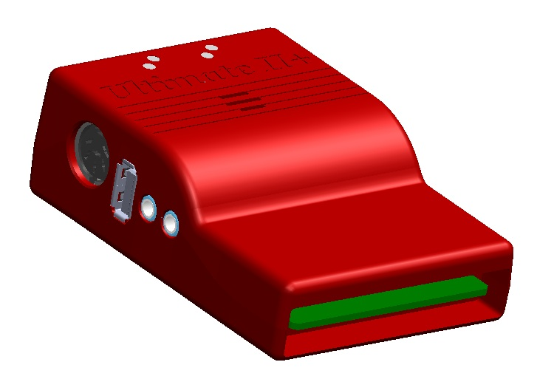

C64

Cartridge Port

USB 2

Tape port

Bottom

Speaker

LEDs

Audio

Line In

Audio

Line Out

IEC

Port

**Concept of operation**

The main feature of the Ultimate-II+ is a cycle accurate implementation of the Commodore 1541 Floppy Disk Drive. This part of the Ultimate-II+ cartridge thus acts exactly like a real drive. It is not any faster or any slower than a real floppy disk drive.

Just like a real 1541 disk drive, the Ultimate-II+ needs “floppy disks”. On the Ultimate-II+, these floppy disks are *virtual*. These virtual disks exist in the form of a .D64 or .G64 file on a storage device, such as the supplied USB stick. When the user selects such a file, it is linked to the emulated drive. This process is called *‘mounting’*. After mounting (which will take a few seconds to complete), the 1541 can access the image file as if it was a real floppy. All standard commands that you are familiar with while using a real CBM1541 then apply.

**The Menu**

The Ultimate-II+ provides a user friendly menu driven interface, which can be accessed by pressing the middle button on the back of the cartridge. Pressing this button will interrupt the currently running program on the C=64 and show the menu. Leaving the menu will resume the C=64 gracefully. The main two functions of the menu are: 1) file selection, 2) configuration of the 1541 Ultimate cartridge.

The menu starts with showing the available network interfaces, and the storage devices that are attached to the cartridge. By default, it will only show the built-in Ethernet port. When USB-sticks are inserted, one or more items will appear in this list. This screen is the ‘root’ of the file system. Use the cursor keys to navigate through the file system and select your file (disk image) to mount. The highlighted line shows the current selection.

Use the keyboard as follows:

*CRSR up/down* Move the cursor (highlighted line) up/down

*CRSR left* Go one level up (leave directory or disk)

*CRSR right* Go one level down (enter directory or disk)

*Return*  Bring up a context menu with actions to be performed on the selected item.

*F1* Page up

*F7* Page down

*F5* Bring up a menu with actions to be performed.

*F2* Enter the setup menu

*F3* Shows the HELP-text

*Quick seek:* Use the keyboard to type the name to search for. You can use ‘?’ as a wildcard.

*Space* Select / deselect entries in the file browser for copying.

*C=C / C=V* Control-C / Control-V can be used to copy files between locations, just like in Windows. Be aware that file copy is a lot slower than on a modern PC.

*RUN/STOP* Leave the menu.

**More about mounting disks**

Remember that ‘mounting’ a disk means creating a link between the 1541 part of your ultimate cartridge, and a file on a storage device. This means, that when the link has been established, “writes” that the 1541 performs will be written back into the disk image file as well. In this way, the ‘real’ behavior of a floppy is emulated.

This behavior will not always be what you want. There are two options to avoid this: ‘mount’ the floppy as read-only, or ‘mount’ the floppy in ‘unlinked’ mode. When write protected, the drive itself cannot write to the floppy. In unlinked mode, the writes to the floppy are performed, but do not reflect in the .D64 or .G64 file. When the storage device is removed, the 1541 drive automatically switches to unlinked mode. Be aware that writes to the disk will then be lost when you turn off the machine.

**LEDs**

The Ultimate-II+ has four LEDs that are visible on the outside of the plastic case:

1. Green: 1541 drive power
2. Red: 1541 drive status
3. Yellow: Cartridge active
4. Green: Storage activity

The drive power LED has four states:

* Off: The drive is not powered
* Dim: Powered, but no disk mounted
* Half bright: Powered and disk mounted, motor off
* Bright: Powered, disk mounted and motor running.

**Cartridge Emulation**

Because the Ultimate-II+ will occupy your cartridge slot, a list of popular expansions available for the C=64 are integrated into the Ultimate-II+. These expansions include cartridges such as the Action Replay, Retro Replay, The Final Cartridge III, Super Snapshot V5, KCS Power Cartridge and the Epyx fastloader. In the configuration menu, even the CBM1750/1764 RAM Expansion unit can be enabled, with expansion RAM up to 16 MB!

Many of these cartridges have a reset button and a freezer button. This is the function of the other two buttons on the Ultimate-II+. By default, the left button is the freezer button, and the button on the right is the reset-button. Through the configuration menu, the buttons can be swapped if desired.

**Configuration**

As mentioned above, you can enter the configuration menu by pressing ‘F2’ while you are in the menu structure. This will bring up a screen with the following items:

* Clock Settings
* Audio Output Settings
* Software IEC settings
* C64 and cartridge settings
* User Interface Settings
* 1541 Drive Settings
* Network Settings

Use the UP/DOWN cursor keys to navigate and RIGHT to enter the desired configuration screen. Once inside a settings screen, the behavior of the keyboard is slightly different:

*CRSR up/down* Move the cursor (highlighted line) up/down

*CRSR left/right* Increase or decrease a setting, cycling through the available options.

*DEL* Go one level up

*Return / Space* For string fields: bring up a text entry box

For enumerated fields: bring up a context menu with the available options

*Run-stop[1] Leaves* the configuration menu and saves the new values.

Note that some values will only take effect after reset or a power cycle of your C=64. However, the main menu provides a way to restart the 1541 and the C=64 with the new settings.

**Ethernet**

Some of you may be familiar with the RR-net solution that brings Ethernet to the C-64. Currently, the built-in Ethernet port does *not* provide RR-net compatibility. However:

The Ethernet port is used natively by the firmware. There is some primitive support for file-transfer using FTP (needs improvement), and it is possible to connect to the Ultimate-II+ using a VT-100 terminal program on the Telnet port (port 23). This gives the possibility to control the machine remotely, and swap disks without actually interrupting the program running on the C-64.

**USB support**

The Ultimate-II+ supports most USB sticks and Flash card readers out of the box. It also supports USB 2.0 Hubs. It is recommended to use powered USB hubs only (with an external power supply). USB 1.1 Hubs are *not* supported.

There are three USB 2.0 ports available on the cartridge; two on the right and one on the left side. Please note that the port on the left is ***not*** a USB 3.0 port. Although you may use this port as a 2.0 port, it is not USB 3.0 compliant. The extra signals on a USB 3.0 connector are used to communicate with the tape port (see below). ***Please do not attempt to attach a USB 3.0 device to the blue USB connector on the Ultimate-II+.*** You may safely use a USB 3.0 device on the *right* side of the cartridge.

**File Systems**

Currently, the Ultimate-II+ supports the FAT16/FAT32 file system on any storage device, and the ISO9660/Joliet on CD/DVD ROM drives, or ISO files. It is able to read D64 files, as well as D71 and D81 files (no partitions), T64 files.

**DMA loads**

The Ultimate-II+ is capable of loading files directly through the cartridge port into the memory of your C=64. This is called DMA load. The menu supports loading files of the .PRG type only. It doesn’t matter if the PRG is located on the FAT/ISO file system, or inside a disk image (.D64), or inside a tape archive (.T64). Be aware that a lot of programs inside a .D64 file require that the rest of the disk is mounted in the drive. For those programs, use the ‘Mount & Run’ command.

**Tape** **Support**

The Ultimate-II+ is capable of emulating a cassette tape deck (CBM1530/1531). To use this function, a special adapter set connects the Ultimate-II+ to the tape port of your C=64 computer. This tape adaptor set can be purchased separately.

In order to play a tape, browse in the menu to a .TAP file, and press enter and select “Play Tape” from the popup menu. This will initialize the tape streamer from the start of the tape. Use functions in the main menu (F5) to pause/resume playback. It is also possible to write the .TAP file to a real tape, using a CBM1530/1531 deck.

The Ultimate-II+ can also capture tape signals into a .TAP file. The ‘F5’ menu will show you the available options.

**Audio**

The green audio connector on the left side of your device provides a stereo line-out signal. In the configuration menu, it can be selected what is routed to the output channels. Available options include:

* Stereo SID;
* Ultimate Audio module (for playing samples);
* Tape read/write pins (for listening to the tape beeps);
* Drive sounds.

Technical note: The emulated stereo SID is taking the CPU writes from the cartridge slot. Unfortunately, there is no way to tell whether the access is made to the I/O region ($D400-$D7FF), or to the RAM below. The necessary signal to differentiate between the two accesses is simply not available on the cartridge port. For this reason, when software uses the RAM in this area, it is possible that you will hear unintended clicks and pops, or even notes.

The blue line-in connector is not yet used at this point.

Ultimate Audio module

The Ultimate Audio module provides 8 simultaneous sampling voices. This module is utilized as part of the Ultimate-II+ firmware for playing Amiga MOD files. This option is available in the context menu in the file browser.

If you like to do some programming yourself using this sampler, you can enable this module in configuration menu. It then appears in the I/O region. The programming interface is fully documented. Documentation can be downloaded from the official website:

<http://1541ultimate.net/content/download/ultimate_audio_v0.2.pdf>

Note: On the released firmware version 3.0, it is necessary to manually enable both the REU (RAM Expansion Unit), as well as the audio module in order to play MOD files. In the next software update, these settings are automatically selected when playing MOD files.

**Alternate ROMs**

The Ultimate-II+ allows you to use other ROMs for both the emulated 1541 drive, as well as the built-in Kernal ROM of your machine. These ROMs are resident (remembered) by the Ultimate-II+ once they are loaded from the file system.

In order to use an alternate ROM, browse in the file system to the binary ROM file that you like to use. The file should have the ‘.bin’ or ‘.rom’ extension. When you press enter, and the file is of the correct size, the option will appear: “Use as..”. Kernal ROMs should be exactly 8K, and drive ROMs should be exactly 16K or 32K.

NOTE: When you use an invalid file as Kernal replacement, the C64 will no longer boot. However, even when the C64 gives a black screen, you can still enter the configuration menu in order to disable the Kernal replacement option.

**Software IEC**

The Software-IEC module is a serial bus service that can be enabled in the configuration menu. This module provides two additional devices on the Commodore serial bus; the IEC bus:

* Virtual drive that gives direct access to the Ultimate-II+ file system;
* A virtual printer

Printer

The virtual printer is a valuable contribution created by René Garcia. It takes printer commands from the Commodore 64, and creates a black and white image of the printed graphics and text. This image is then saved to the USB flash drive. The full documentation of the printer emulation and all of its capabilities and options is available here:

<http://1541ultimate.net/content/download/mps_printer_emulation.pdf>

Virtual drive

The virtual drive can only be used to access files of the file system, through the OPEN/CLOSE commands on the IEC bus. By default, the path of the IEC drive is ‘/Usb0’, which is the top most USB connector on the right of the unit. This default path can be changed in the configuration menu. When the USB drive contains a program ‘TEST.PRG’, it can be loaded with the basic command LOAD"TEST.PRG",10. Similarly, you can save your programs with the SAVE command. When loading the directory (LOAD "$",10), the path will be shown as disk name.

The command channel 15, can currently only be used to change the current directory. Just like on modern systems, “..” is the parent directory and “/” is the root directory:

OPEN 15,10,15,"CD:/USB1/MYPROGRAMS":CLOSE 15

At this point, the virtual drive is not JiffyDOS compliant.

**Ultimate Command Interface**

Since some time, it has become possible to control the Ultimate-II programmatically through the I/O port of the C64, thus from a program that runs on the machine. This is useful for many things; for example it can be used to access the file system much faster than through the serial bus. But it can also be used to load files from the file system into REU memory for example. The set of commands grows over time and will provide more and more powerful features.

Documentation of the interface itself is available here:

<http://1541ultimate.net/content/download/command_interface_v1.0.pdf>

Accessing the file system is done through the “DOS” target, which is documented here:

<http://1541ultimate.net/content/download/ultimate_dos_v1.0.pdf>

**Real Time Clock**

For getting correct time stamps on the files that are created on the USB pen drives, the Ultimate-II+ offers a real time clock (RTC) function. This RTC can be set through the configuration menu.

The RTC is powered by a CR2032 battery, which is located inside of the unit. Calculations show that the lifetime of this battery is several years.

**Website**

Consult the website [**http://www.1541ultimate.net**](http://www.1541ultimate.net) for more information, or for questions regarding your device, or you may join the Facebook group “1541 Ultimate”.

**Disclaimer:**

The ‘firmware’ on your Ultimate-II+ board consists of a rather large number of functional parts that all work together. Although an insane number of hours have been put into testing and improving the firmware and software, I am very certain that it still has bugs. Some testing work still needs to be done. The device will be improved further as time passes. Check the download section at the website for the newest firmware version. We believe in the end this will sure be the ‘ultimate’ storage solution for your 8-bit Commodore computer.

**Known issues:**

* The processing speed of the Ultimate-II+ is currently (V3.0) still quite a bit lower than the Ultimate-II. This is because the Ultimate-II+ platform does not have instruction/data caches still on its embedded processor. The lower speed may cause some situations in which the unit appears to hang, while it is just busy. For example, when the unit is trying to find a free sector on a large USB stick (and note: even 8 GB is already huge!), it may take up to half a minute or so, before the first file can be written, or the first directory can be created. Similarly, when using the printer emulation, the conversion from a bitmap image to a PNG file can take quite some time. This problem can (and will) be solved in a future software upgrade.
* The built-in speaker may produce a hissing interference sound. This is primarily observed with some low cost USB phone chargers and thin MicroUSB cables. It is clearly power supply related, but it is a hardware issue that still needs further investigation. It cannot be solved with a software upgrade.
* The built-in speaker produces some clicks when the unit is powered up. This will be solved in the next board revision. It cannot be solved with a software upgrade.

Other issues can be found (and reported) here:

<http://1541ultimate.net/content/index.php?option=com_issueform&Itemid=24>

1. On VT-100, use backspace instead of RUN STOP